Determined Mail: Your Everyday Email Sight

Group TBD

**Table of Contents**

**Design 1: Single Page Inbox or Email** **2**

Hierarchical Task Analysis 2

Interface Mockups 4

Design Walk Through 6

Strengths & Weaknesses 6

**Design 2: New Tab Email** **7**

Hierarchical Task Analysis 7

Interface Mockups 8

Design Walk Through 10

Strengths & Weaknesses 10

**Design 3: Split Page Inbox + Email** **10**

Hierarchical Task Analysis 11

Interface Mockups 13

Design Walk Through 15

Strengths & Weaknesses 16

# 

# **Design 1: Single Page Inbox or Email**

## Hierarchical Task Analysis

Create an Account

## 

Read Email

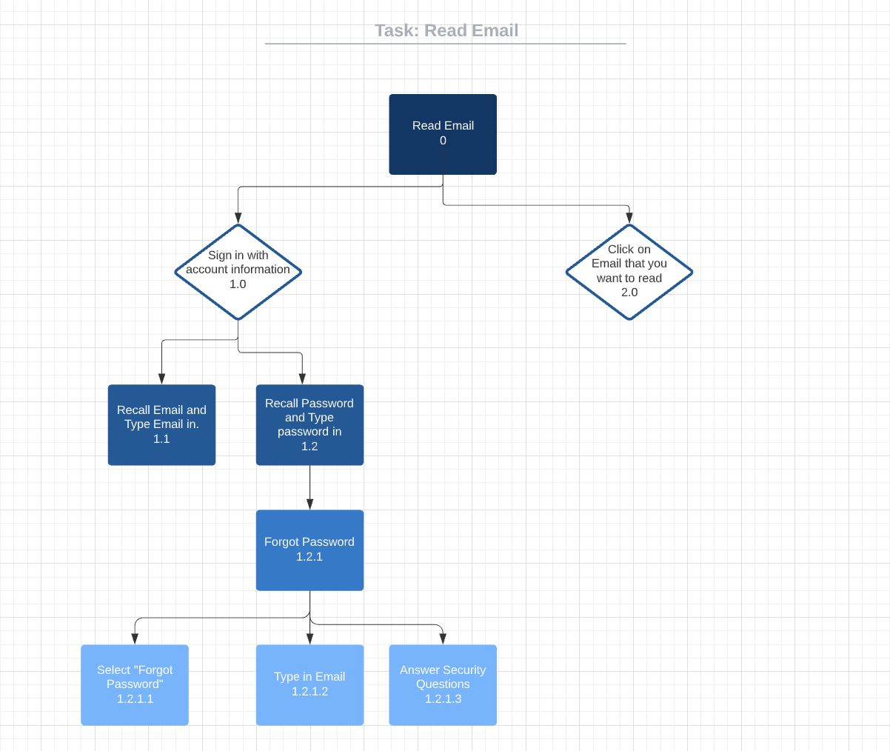

Draft and Send an Email

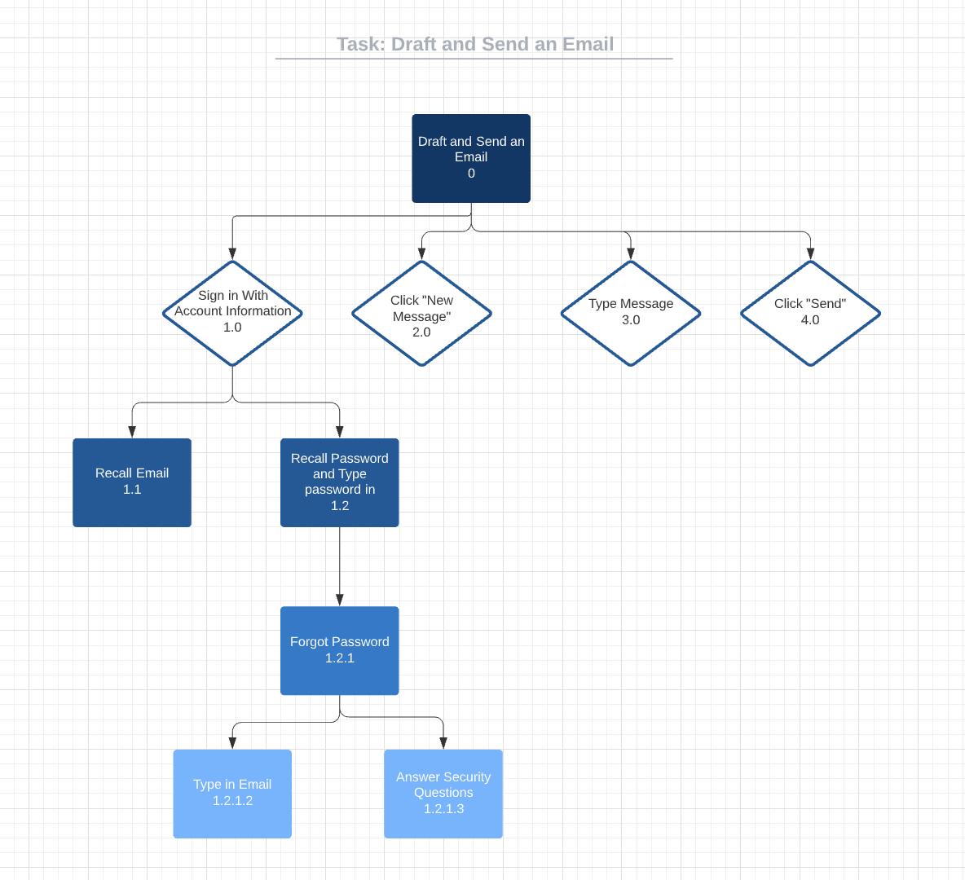

## 

## Interface Mockups

Sign In

### 

### 

Inbox View

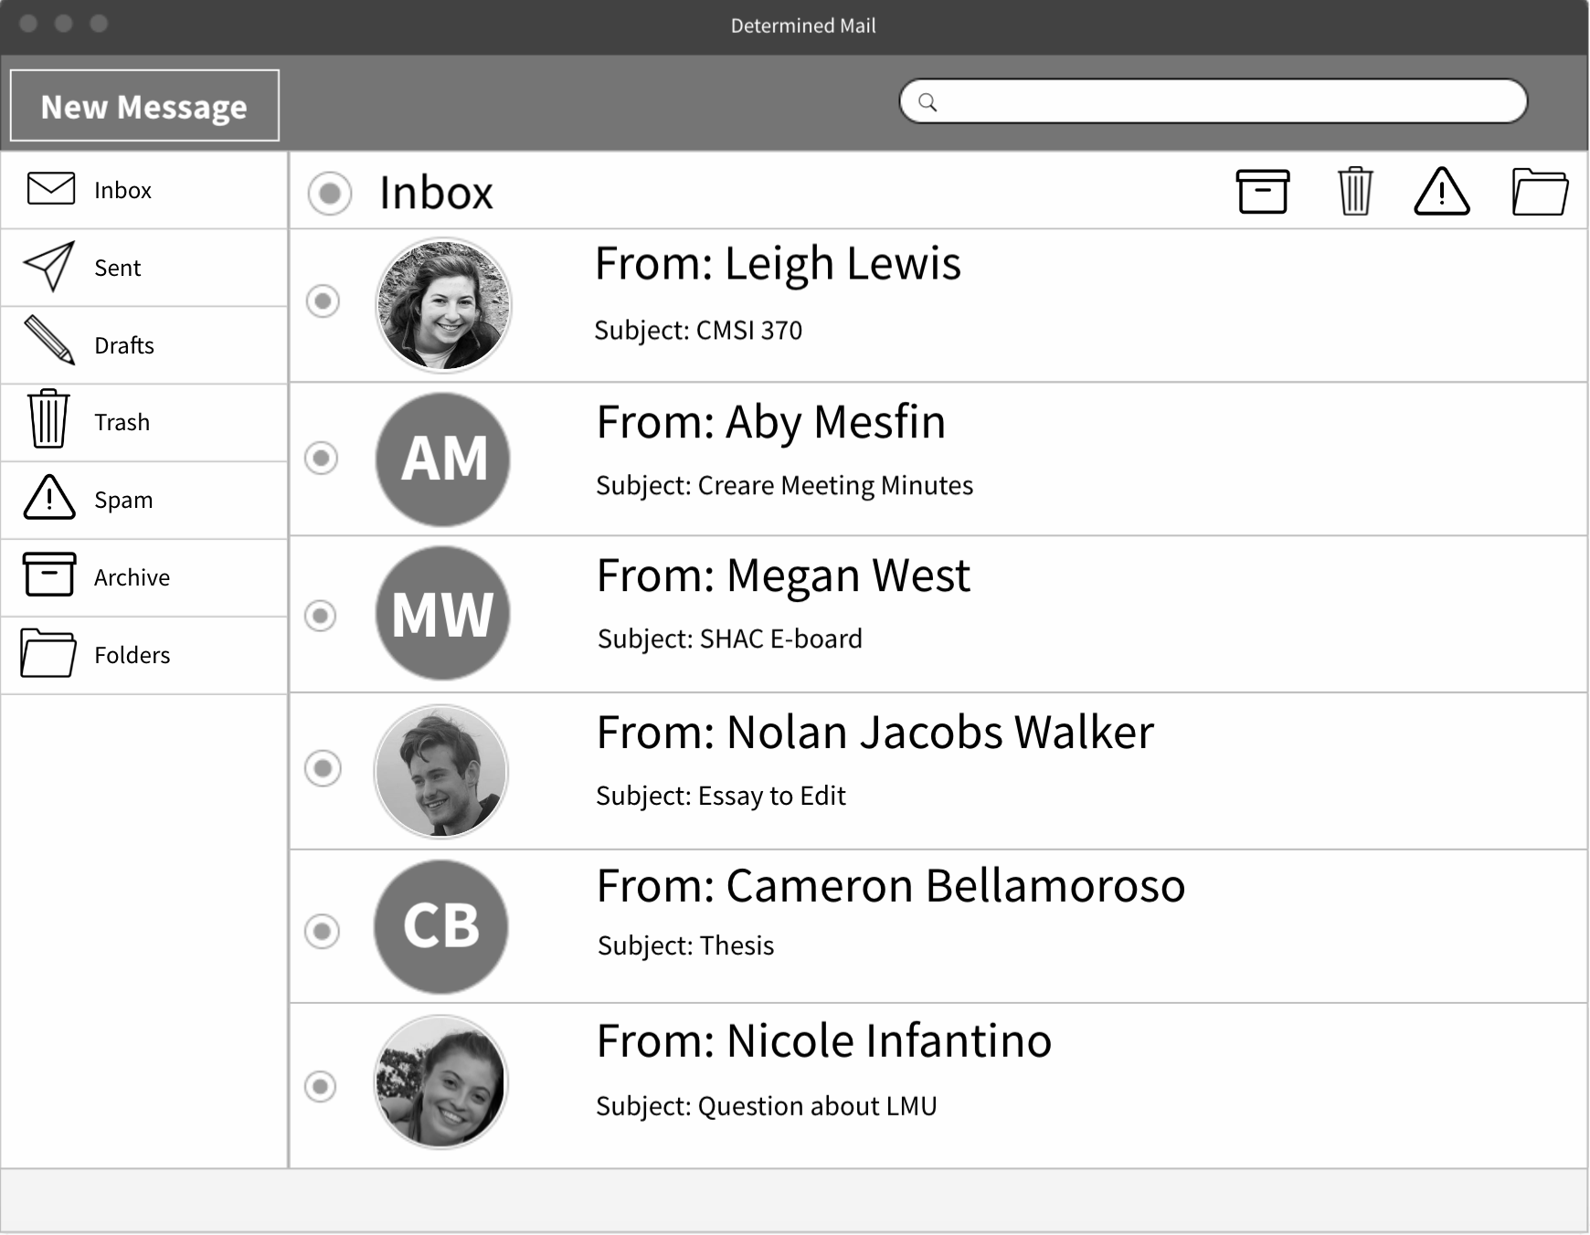

Draft an Email

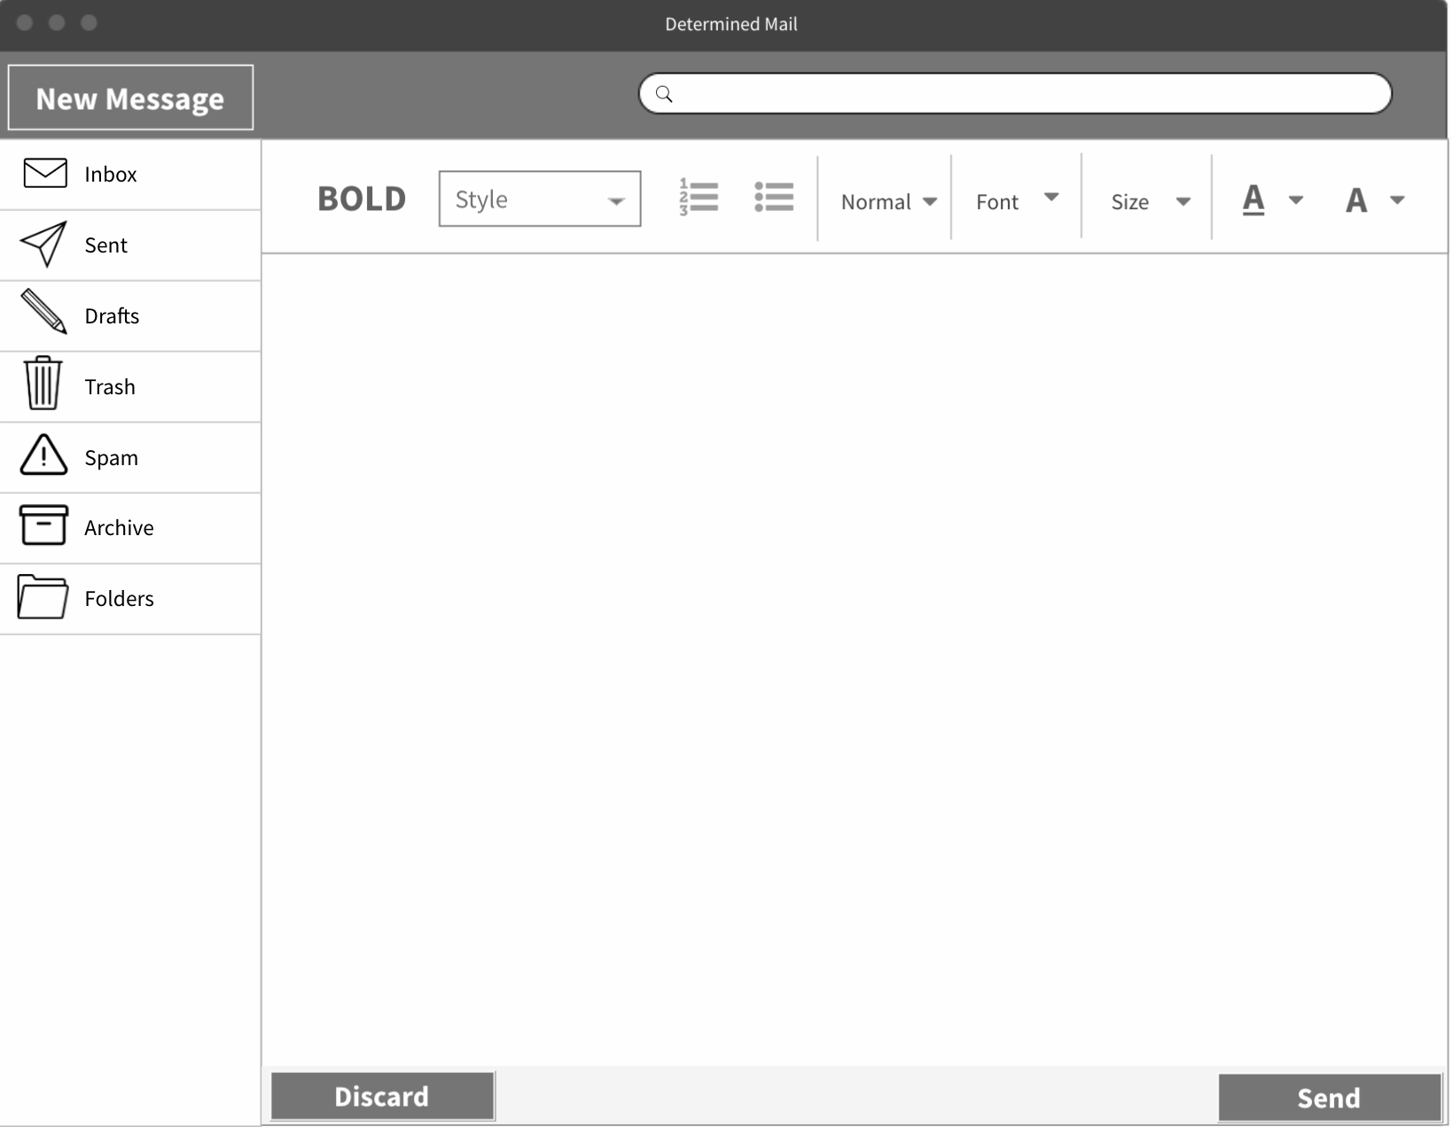

Read Email

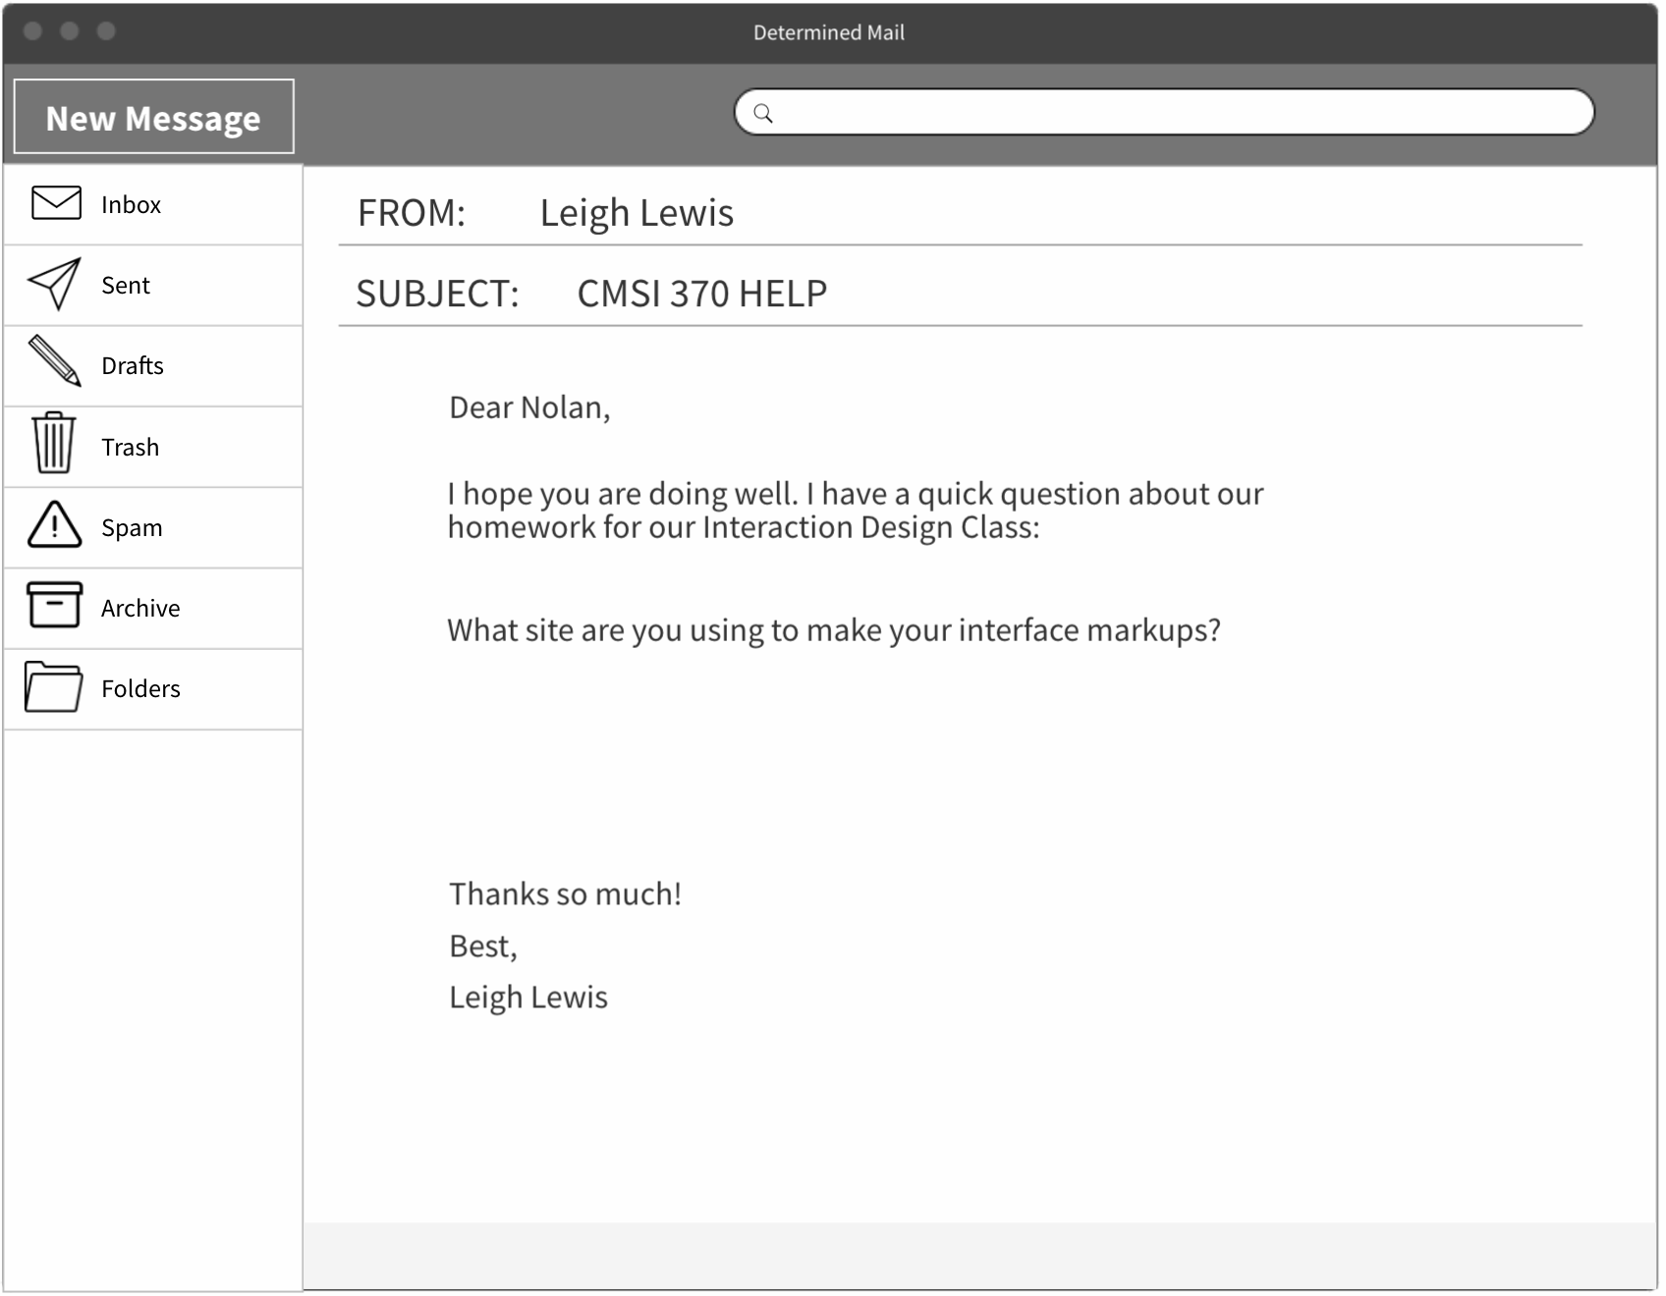

## 

## Design Walk Through

When the user navigates to the Determined Mail website, they will be taken to the login page. Once the user logs in, they will see their inbox. There is a navigation panel on the left-hand side of the interface that has buttons like, inbox (navigate to the inbox), sent (click to see sent emails, drafts (click to see saved / unsent drafts), trash (click to see deleted emails), spam (click to see emails in the spam folder), archive (click to see archived emails), and folders (click to see folders).

At the top of the site, there is a search bar as well as an archive button, a trash button, a spam button, and a folder button.

Within the inbox, each email shows the profile photograph (or initials) of the sender, the name of the sender, and the subject line. When a user clicks on an email, the email will take up the full page of the site (the left navigation bar will always remain visible to allow users to navigate back to the inbox or start writing a new email).

## Strengths & Weaknesses

Strengths

We chose a grayscale color scheme so it doesn’t distract or overwhelm the user and they can stay on task. The icons on the left menu give cues to the user about what each button does so that the user doesn’t need to spend time deciphering the words. For example, if the user is in a rush and needs to access their Archives, the box icon is clear and distinct from the other icons so the user can find it easily, as opposed to spending time reading down the menu and finding the title of the page they need.

Weaknesses

Font customization buttons could be changed to icons, for example the Size button could be an Aa so it’s fewer letters and the Style and Normal dropdown menus could be combined into one. We are still discussing specifics and figuring out what the right amount of customization options will be so that the user maintains a sense of control over their content without feeling overwhelmed with options and encounters the paradox of choice.

# **Design 2: New Tab Email**

## Hierarchical Task Analysis

Read Email

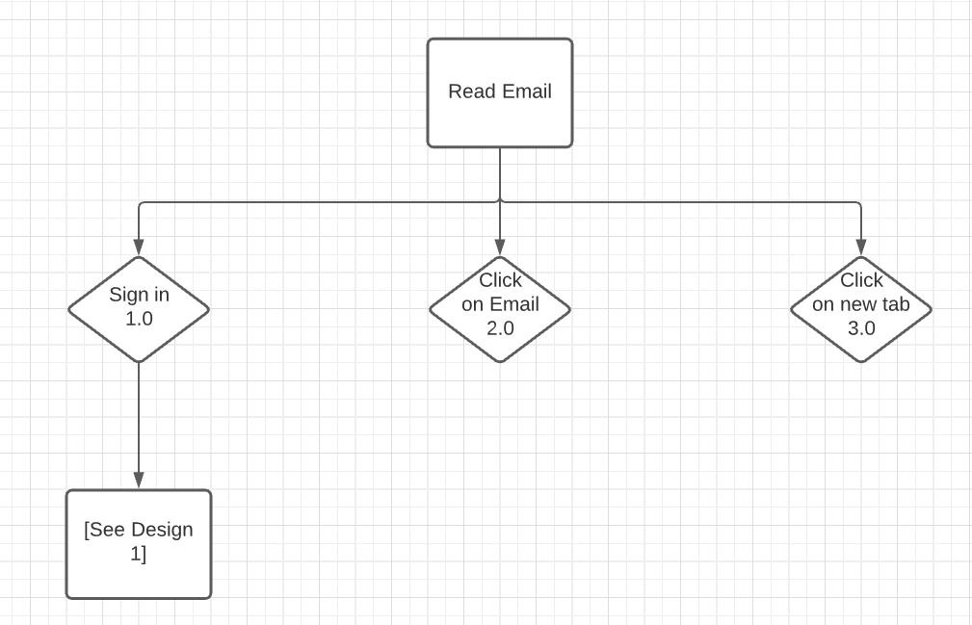

Write Email

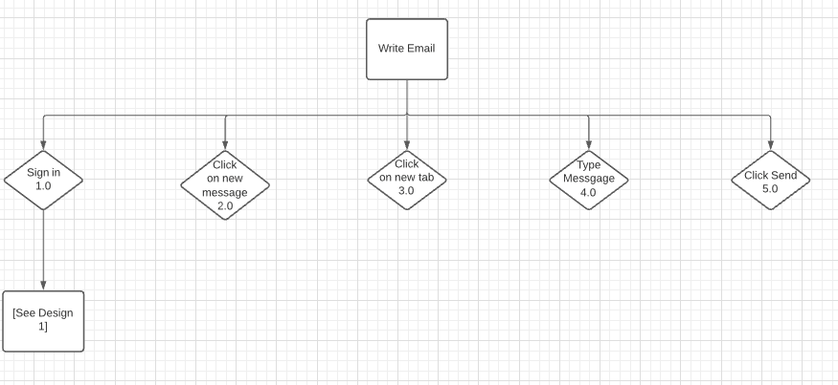

## Interface Mockups

The landing page (login) is identical to the previous design.

Inbox View

## 

Draft Email Tab



Read Email

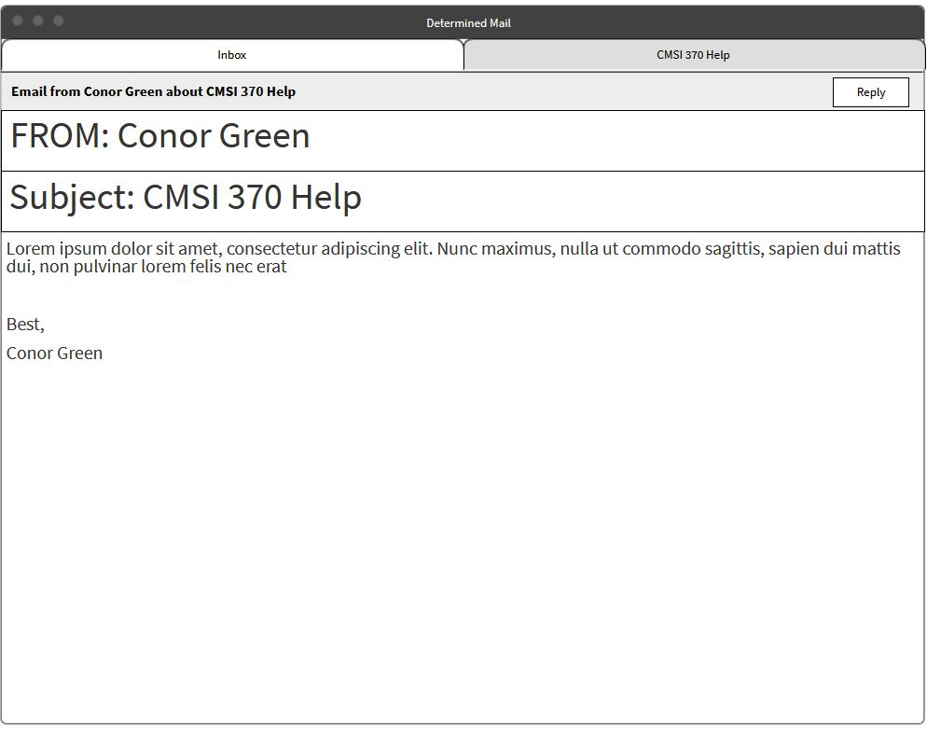

## Design Walk Through

The user starts on the Inbox page and sees a single column layout of emails received, with photos and names of the senders, a subject line, and a trash icon. If desired, the user can type into the search box above to find a given email so that they don’t need to scroll to find it. The email tabs to the right of the Inbox tab indicate open Emails that aren’t currently visible (but are easily accessible!). For this design we wanted to focus on usability and navigational flow, resulting in this being the simplest of the three presented.

The next page is the Draft Email Tab, which shows font style and bullet point options. Maintaining the theme of simplicity, the only buttons other than customization are Discard and Send.The final page is for reading emails, in which the sender’s name, subject line, and email body are present. Above, the Inbox tab is visible along with the highlighted tab indicating that the user is viewing the email *CMSI370 Help*. In the top right corner there’s a Reply button and the top left corner has a description of the email, its sender, and its subject line in a complete sentence so that the user can read that line first and have an idea of what it is they’re viewing.

## Strengths & Weaknesses

This design is extremely simple and easy to navigate. Screen readers would easily be able to use this layout. And, clearly, little to no color is necessary, so those with issues seeing color can still use our design. By opening new tabs instead of changing the current screen, clutter is kept to a minimum. Large fonts and pictures are easy to read on this design.

However, it is simplicity to the extreme. Those who are adapted to normal, robust inbox displays might find it off putting and confusing since it removes many features and simplifies. Finding ‘other’ pages, like Spam requires clicking on a 3-dot button, which is unusual and often harder to find. Power users would find this inbox frustrating due to the simplification. The lack of color makes it boring and hard to focus on, so perhaps color will be added. Though, making color an essential part of the design is counterproductive to the point of this design, so it must remain merely decoration. Finally, large inbox operations are impossible in this design, again as a simplification method.

For those wishing to check their email, read an email, and write an email, this option works. For those power users who want to do more with their email, this would be counterproductive and difficult to use.

# **Design 3: Split Page Inbox + Email**

## Hierarchical Task Analysis

Add an account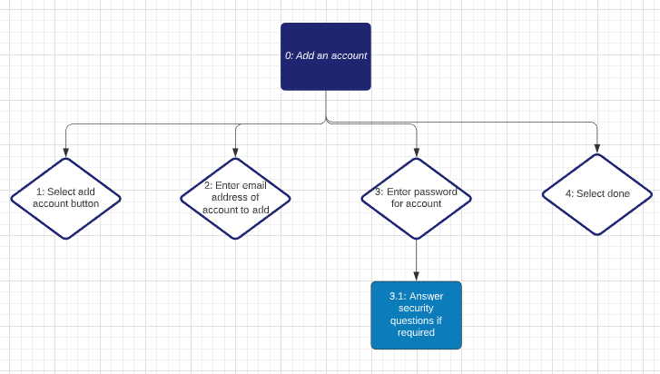

Write an email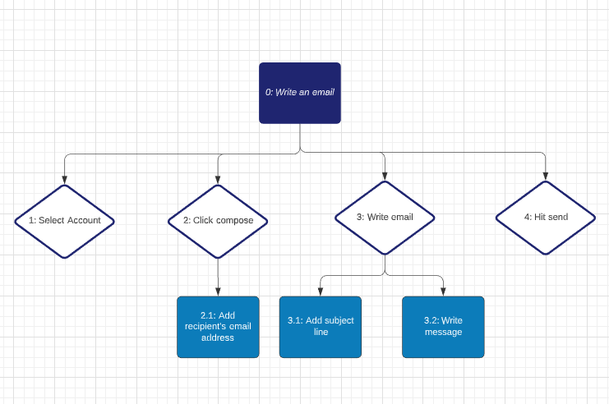

Reply to an email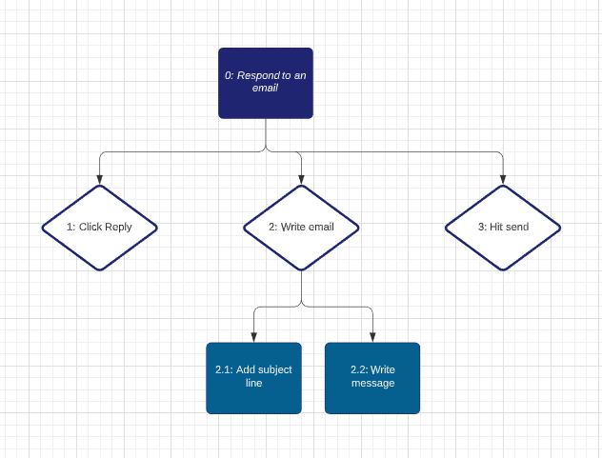

Archive an email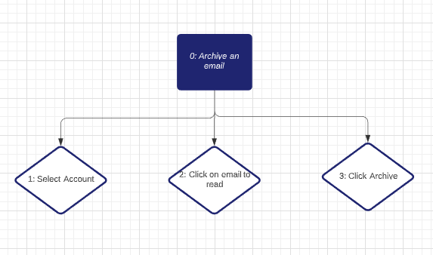

## Interface Mockups

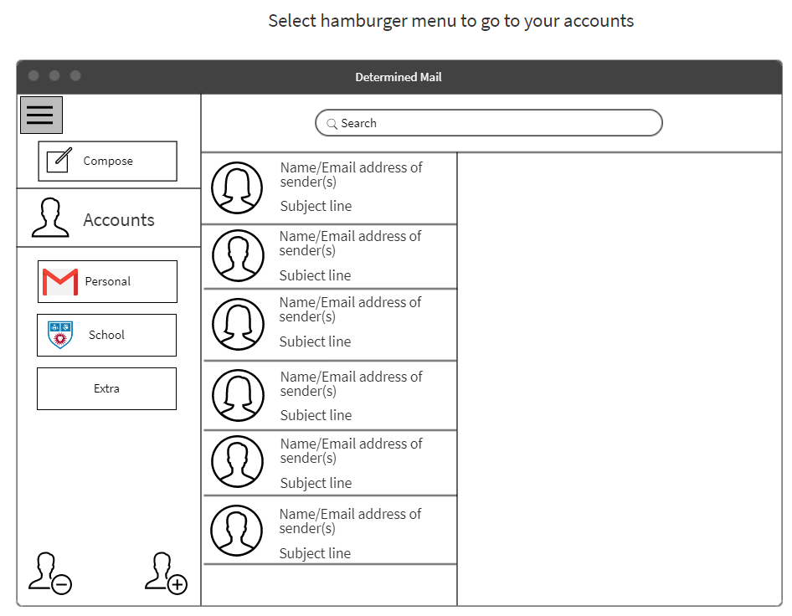

Initially starts on this page, if you want to switch between accounts after you’ve already picked an account then click hamburger menu to get to this page

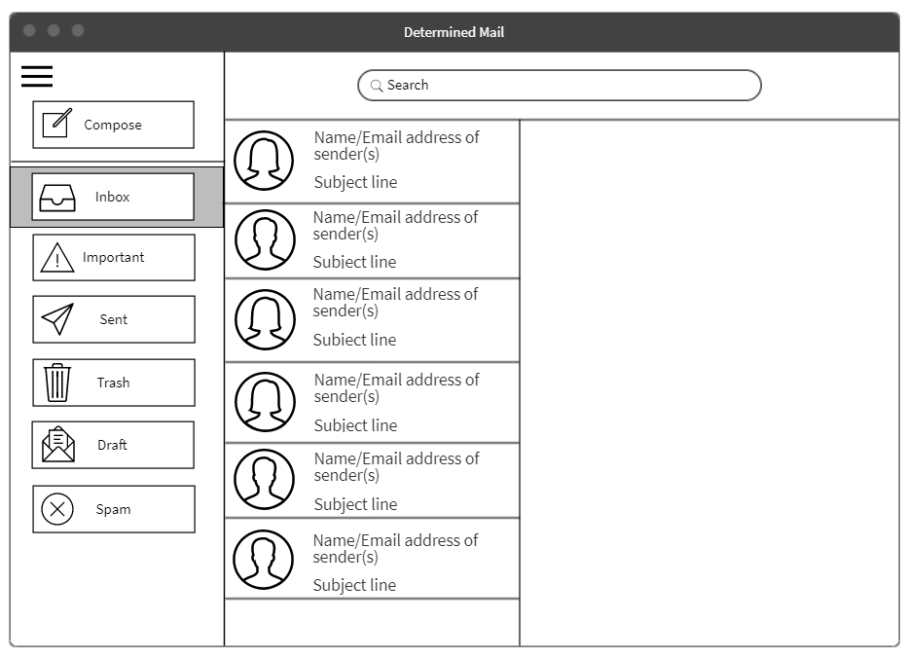

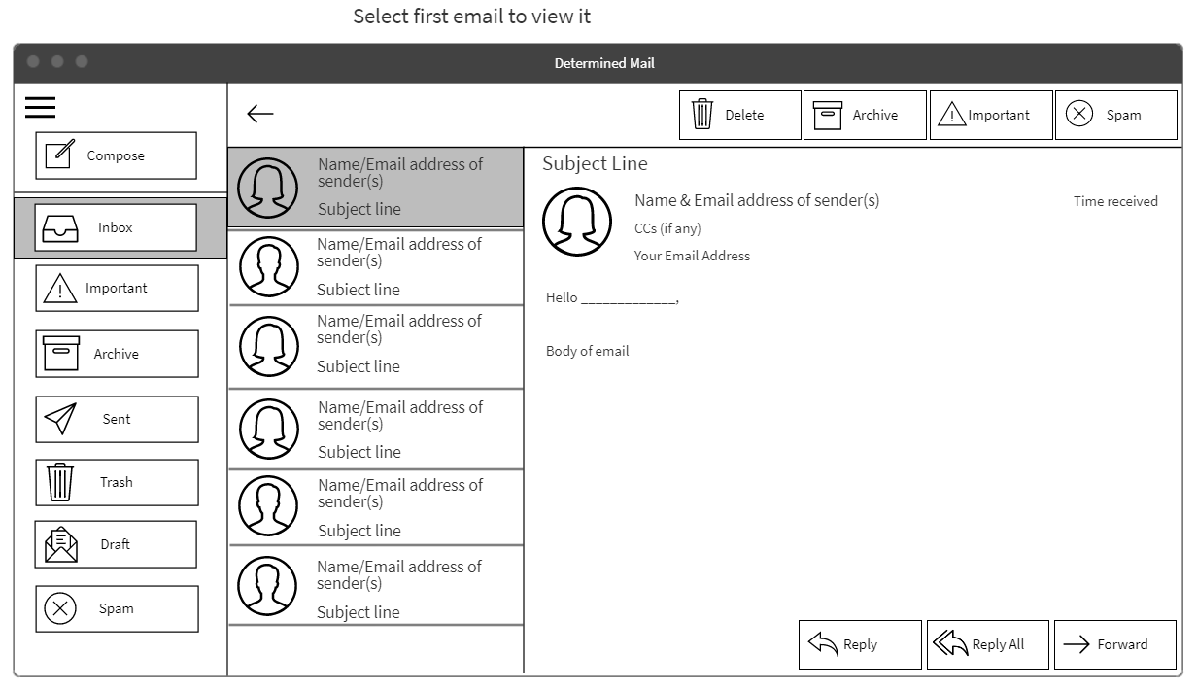

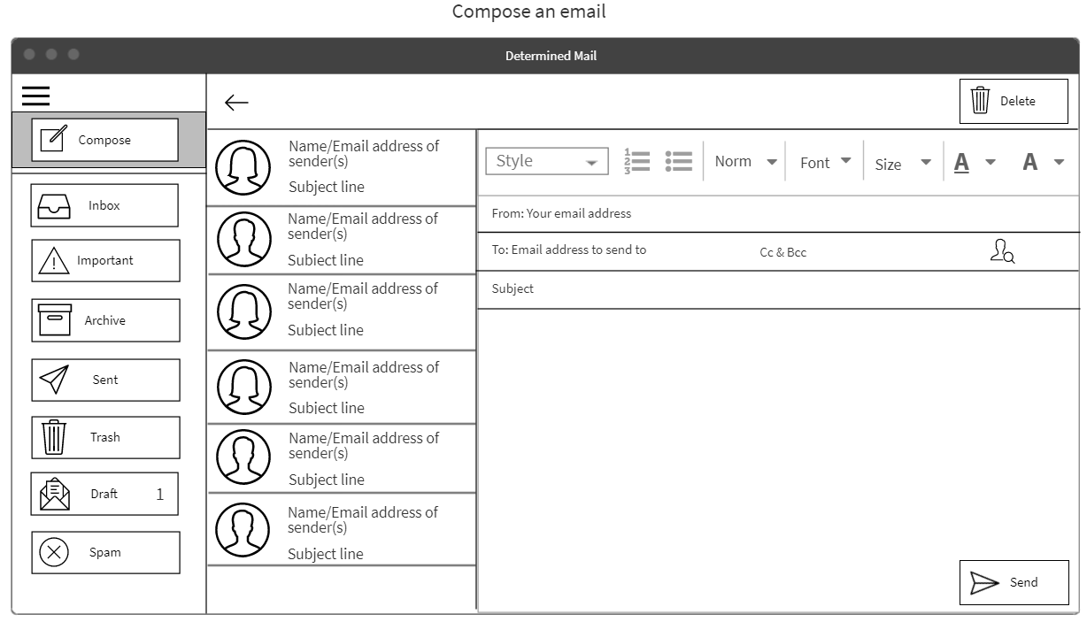

Highlights what you are doing

Immediately puts this email in Drafts until sent

Size will not be able to go smaller than set size, and font will only be one or two specified that are meant to be easily readable

No options for Bolding, Italicizing, or Underlining

Instead of typing persons email address, can click search person Icon to look for them in contacts list

## Design Walk Through

The first page is the inbox page, with a menu on the left column for account selection, the middle column displays sender names and subject lines of Inbox emails, and the right column is empty until the user clicks on the email they want to view. Once the user clicks on the account they wish to use, they can click the hamburger icon and open up a column which replaces the account selection menu and instead displays buttons which redirect the user to different folders.

This design has the same features as the other two, but keeps the email the user wants to view, Inbox list, and menu options all on one screen in different columns. Similarly to Design 2, this one boasts a monochromatic scheme.

## Strengths & Weaknesses

Strengths:

This design is pretty much exactly like the current designs used in gmail or outlook but without the option to bold/italicize text or make the text smaller. Since this design is similar to those already used, it will be easy for users to get used to using it. Most of the buttons are large and at the edges which make them easy to access. Having all the emails in your inbox available means you can easily switch between emails. Having a lot of options on the screen makes it easy to navigate from one part to another.

Weaknesses:

This design has a lot of text on the screen which is what we want to eliminate so that those with dyslexia and other sight/language based disabilities have an easier time using this product. Some of the buttons could be changed to be just pictures to eliminate some of the words on the screen. There also is not a lot of color, which can be seen as beneficial but using color can help differentiate between buttons and make what the button is supposed to do clearer.